## Prerequisite :

## PL/SQL

PL/SQL stands for Procedural Language extensions to the Structured Query Language (SQL). SQL is a powerful language for both querying and updating data in relational databases.

# PL/SQL Procedure

The PL/SQL stored procedure or simply a procedure is a PL/SQL block which performs one or more specific tasks. It is just like procedures in other programming languages.

The procedure contains a header and a body.

* **Header:** The header contains the name of the procedure and the parameters or variables passed to the procedure.
* **Body:** The body contains a declaration section, execution section and exception section similar to a general PL/SQL block.

## PL/SQL Create Procedure

**Syntax for creating procedure:**

1. CREATE [OR REPLACE] PROCEDURE procedure_name
2. [ (parameter [,parameter]) ]
3. IS
4. [declaration_section]
5. BEGIN
6. executable_section
7. [EXCEPTION
8. exception_section]
9. END [procedure_name];

**PL/SQL code block for Addition :**

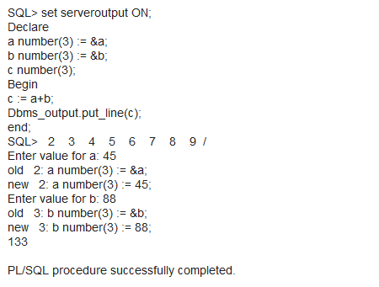

**PL/SQL code block for Multiplication :**

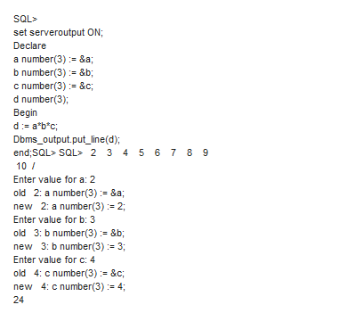

**PL/SQL code block for finding factorial of a number:**

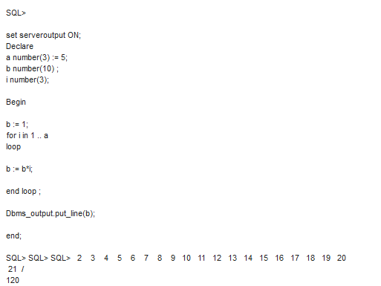

**PL/SQL code block for finding fibonacci series :**

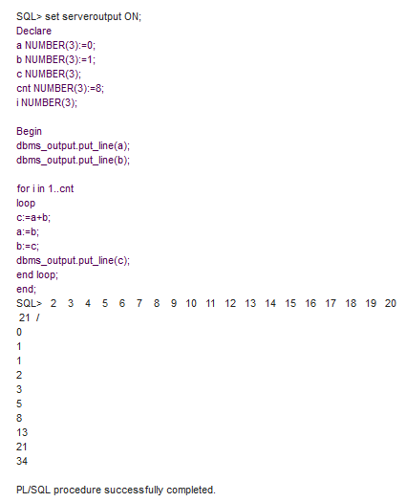

**PL/SQL code block for finding reverse of a list :**

